3D graphs obtained from the response surface method
Y₁ : 3D response surface graphs related to Protein Content of Noodles containing Morio worms
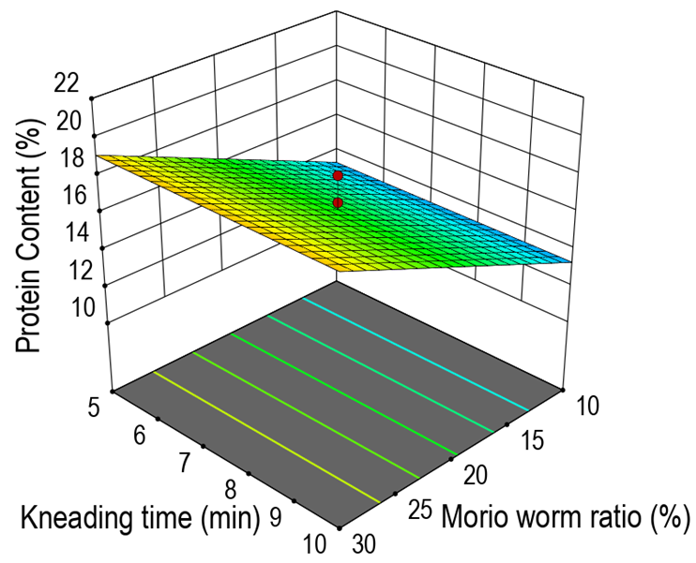

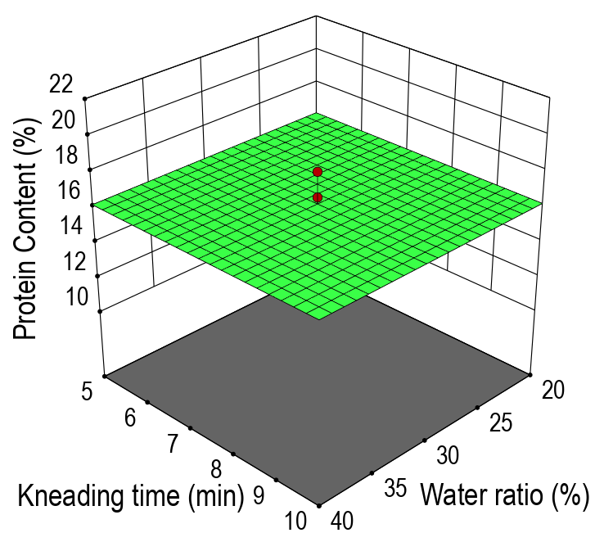
C: Kneading time (min)
B: Water ratio (%)
C: Kneading time (min)
B: Water ratio (%)
A: Morio worm ratio (%)
A: Morio worm ratio (%)
Y₂: 3D response surface graphs related to Saturated/Unsaturated Fatty Acid Ratio of Noodles containing Morio worms
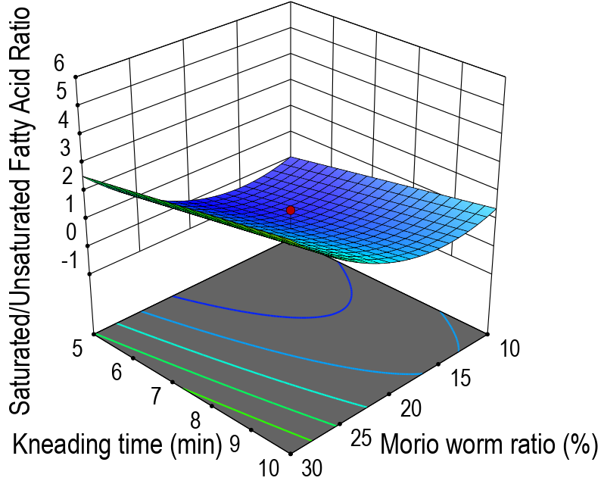

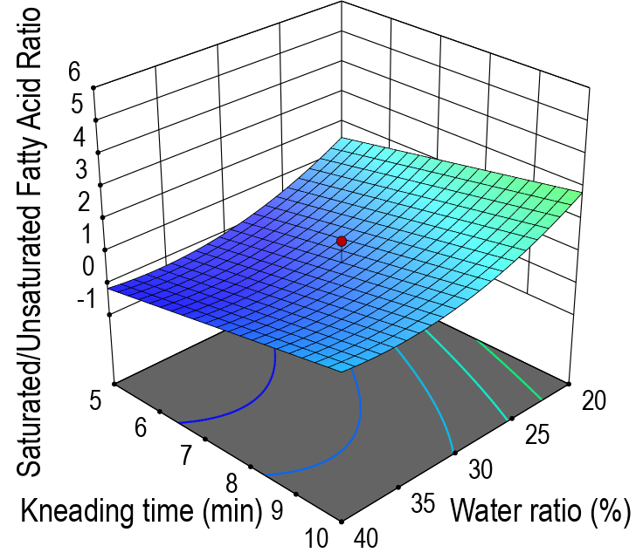
C: Kneading time (min)

A: Morio worm ratio (%)
Saturated/Unsaturated Fatty Acids
Y₃: 3D response surface graphs related to Hardness Values of Noodles containing Morio worms
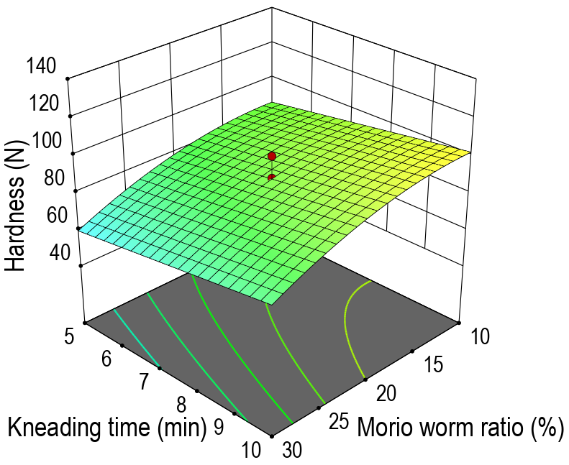

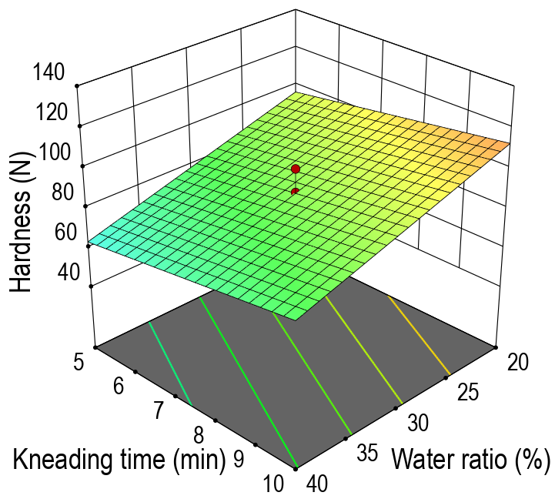
Hardness (N)
A: Morio worm ratio (%)
B: Water ratio (%)
Hardness (N)
A: Morio worm ratio (%)
C: Kneading time (min)
C: Kneading time (min)
B: Water ratio (%)
Y₄: 3D response surface graphs related to L* values Hardness Values of Noodles containing Morio worms

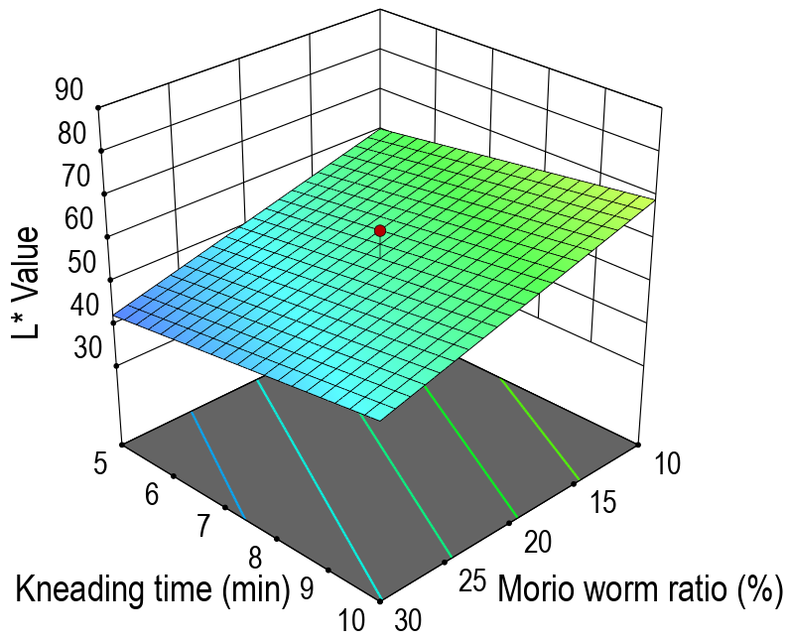

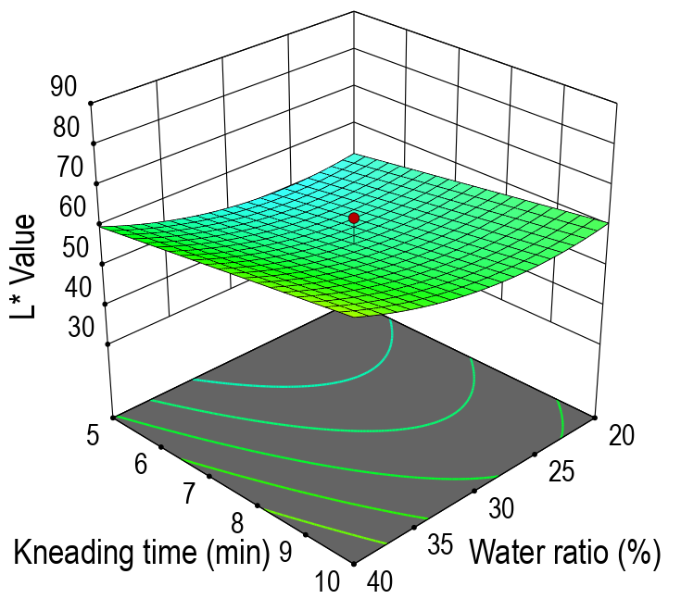
B: Water ratio (%)
C: Kneading time (min)
Y₅ : 3D response surface graphs related to Browning Index Values of Noodles containing Morio worms
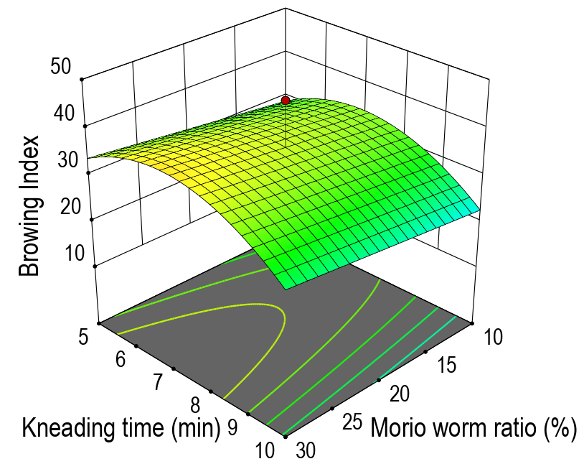

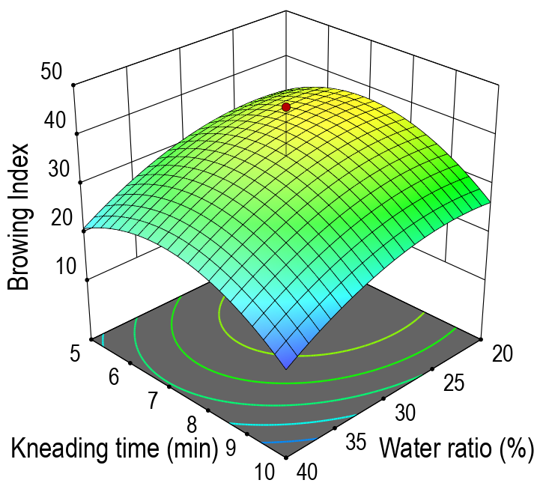
Browning Index
Browning Index
B: Water ratio (%)
A: Morio worm ratio (%)
C: Kneading time (min)
A: Morio worm ratio (%)
B: Water ratio (%)
C: Kneading time (min)
Y₆ : 3D response surface graphs related to Homogenous Structure Values of Noodles containing Morio worms
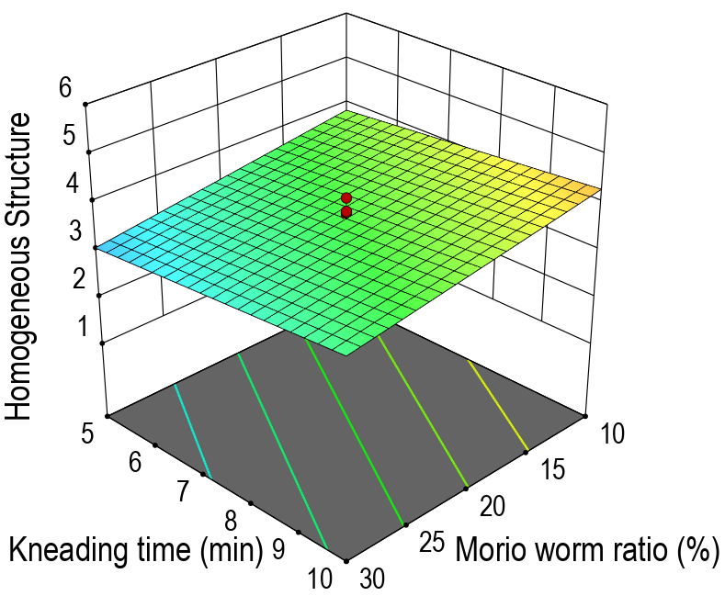

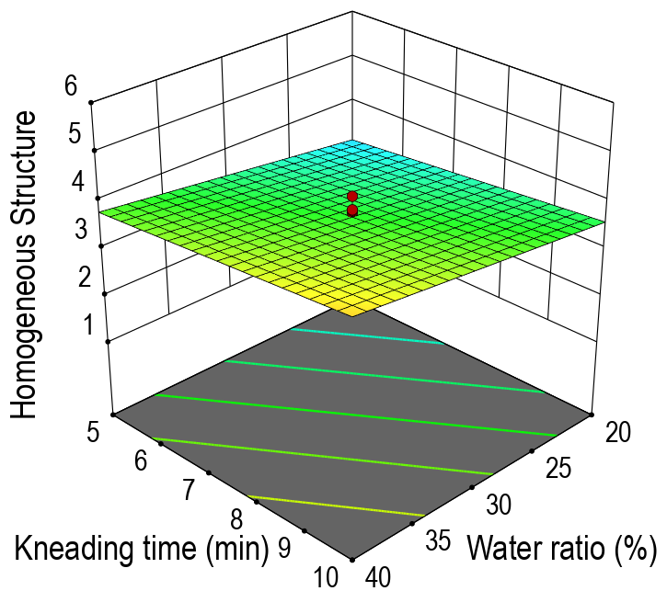
C: Kneading time (min)
A: Morio worm ratio (%)
Y₇: 3D response surface graphs related to Overall Acceptability of Noodles containing Morio worms
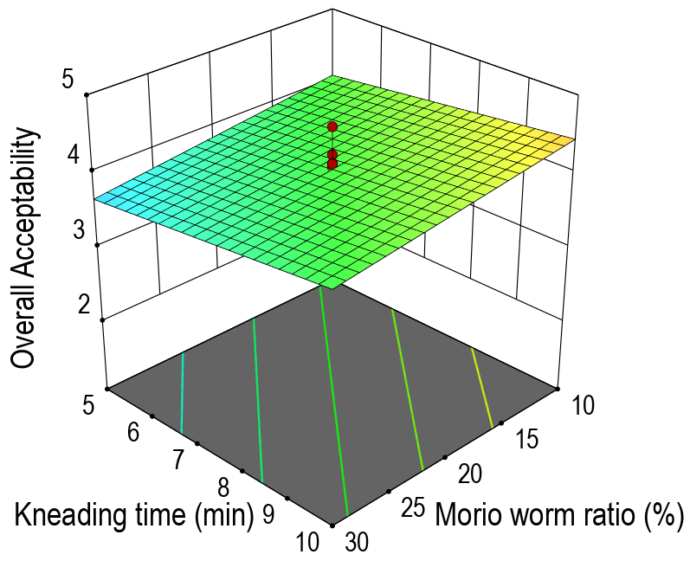

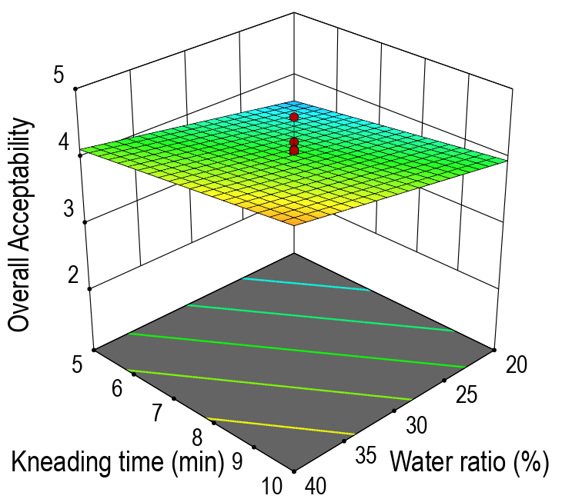
C: Kneading time (min)
A: Morio worm ratio (%)

