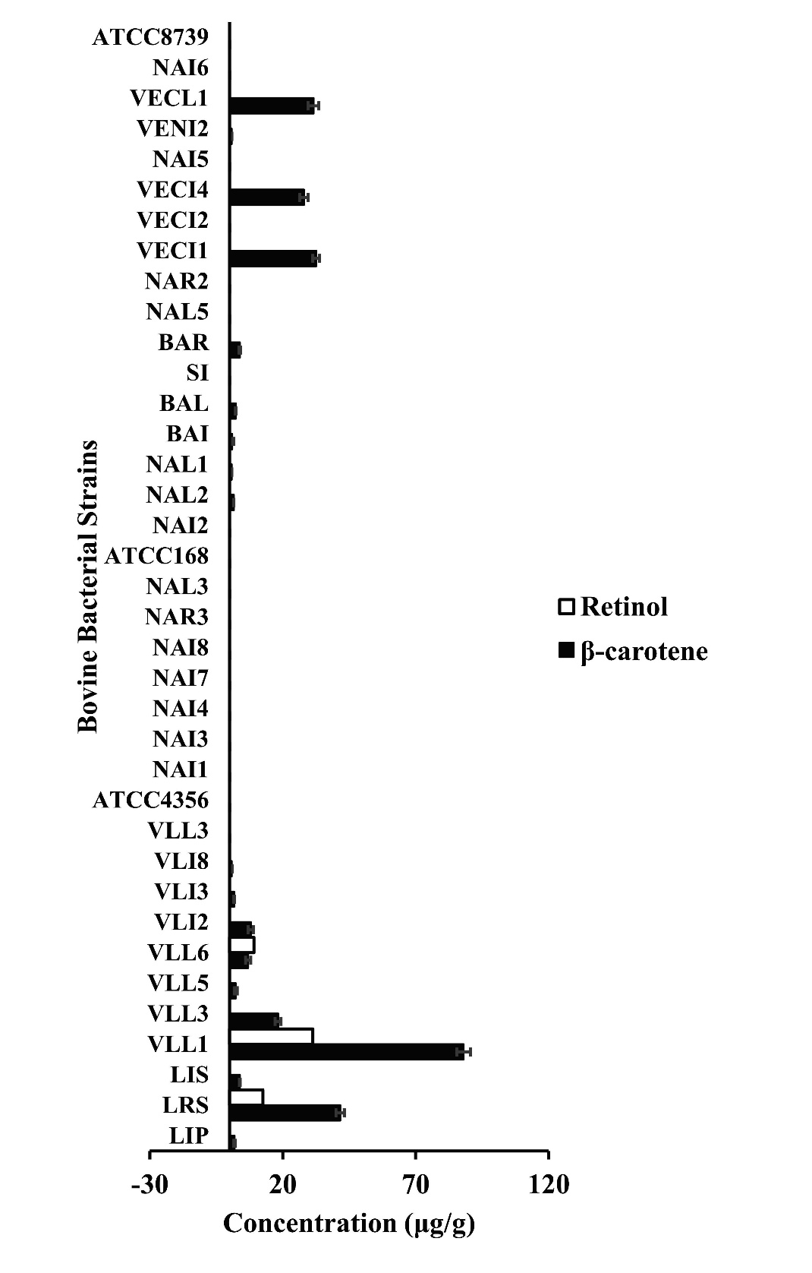

Fig. S1. β-carotene and retinol production of bovine isolates quantified through UV Spectroscopy. The extinction coefficient for β-carotene is 2500 at 460 nm, and retinol is 1835 at 325 nm dissolved in their stock solution respectively. The coefficients of the standard solutions with β-carotene and retinol are y = 0.073x – 0.07 and the r² = 0.9947. Concentrations above 10 μg β-carotene mg⁻¹ dry cell weight were marked with an asterisk and were taken for further experiments.

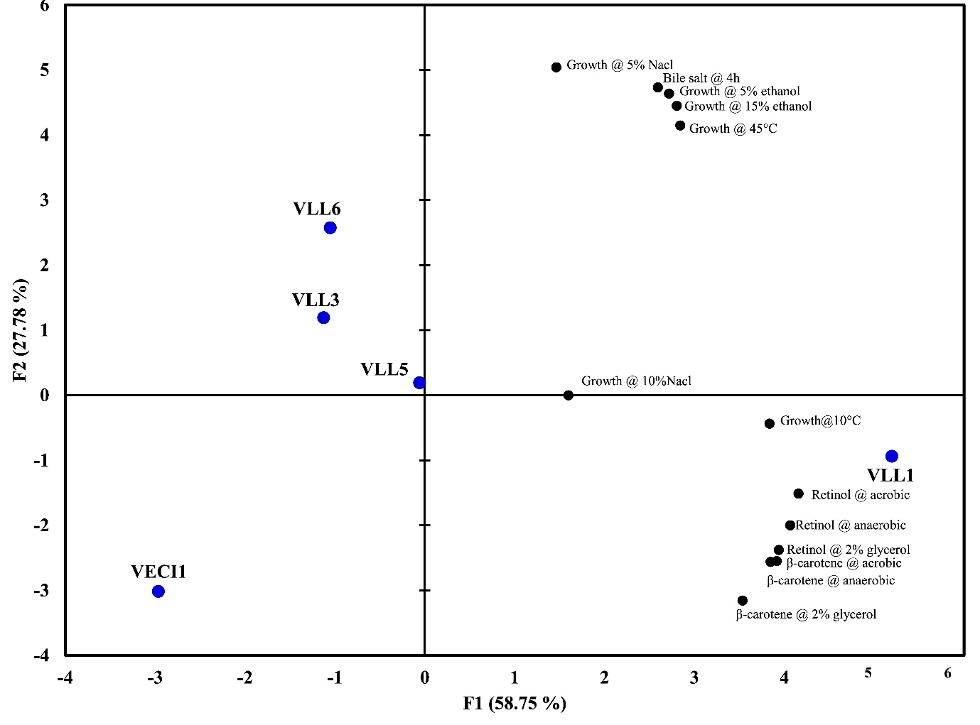
Fig. S2.
Biplot (axes F1 and F2: 86.53%) of principal component analysis visualising the association of the bovine strains at temperature (10 and 45°C), ethanol concentrations (5 and 15% ethanol), bile salt (0.3%), NaCl (5 and 10 %) and β-carotene and retinol production at aerobic and anaerobic conditions. The clustering or position of each strain along the F1 and F2 axes reflects its performance in growth under stress (temperature, NaCl, bile, ethanol) and vitamin A compound production. The absence of data points on the far left simply indicates that, given the range of functional attributes observed among the selected strains, none exhibited profiles that loaded negatively and strongly for these principal components.

Table S1.
MS/MS MRM ions and linearity of β-carotene and retinol in UHPLC/MS-MS
Compound | MRM transition / Mass Ions | Linearity Equation | r²
β-carotene | m/z 536.4 | y = 0.008x + 0.0978 | 0.9674
Retinol | m/z 269 | y = 0.0081x + 0.1037 | 0.9886

Table S2.
Retinol production from bovine bacteria with and without beta-carotene supplementation analysed through UHPLC-MS/MS analysis¹
Strain | Retinol (µg/g dry cell weight)
Strain | Without supplementation | With supplementation of 300 ppm β-carotene
Lactiplantibacillus plantarum VLL5 | 12.58±1.58^{b} | 166.46±4.89^{b}
Lactiplantibacillus plantarum ssp argentoratensis VLL1 | 31.29±2.98ª | 210.74±3.82ª
Lactiplantibacillus plantarum VLL3 | 8.98±1.24^{c} | 67.12±2.58^{d}
Lactiplantibacillus plantarum VLL6 | 9.14±0.85^{c} | 82.24±2.12^{c}
Lactiplantibacillus acidophilus ATCC 4356 | Nil | Nil
Escherichia coli VECI1 | 8.99±0.95^{c} | 55.17±4.12e
Escherichia coli ATCC 8739 | Nil | Nil
¹The retinol content of the bovine bacterial isolates measured through UHPLC-MS/MS. SD denotes standard deviation. The values with different superscript letters differ significantly (P < 0.05).

