SUPPLEMENTARY INFORMATION:
The impact of Three Distinct Probiotic Supplements on the Gut Microbiota and Its Metabolites in Healthy Adults

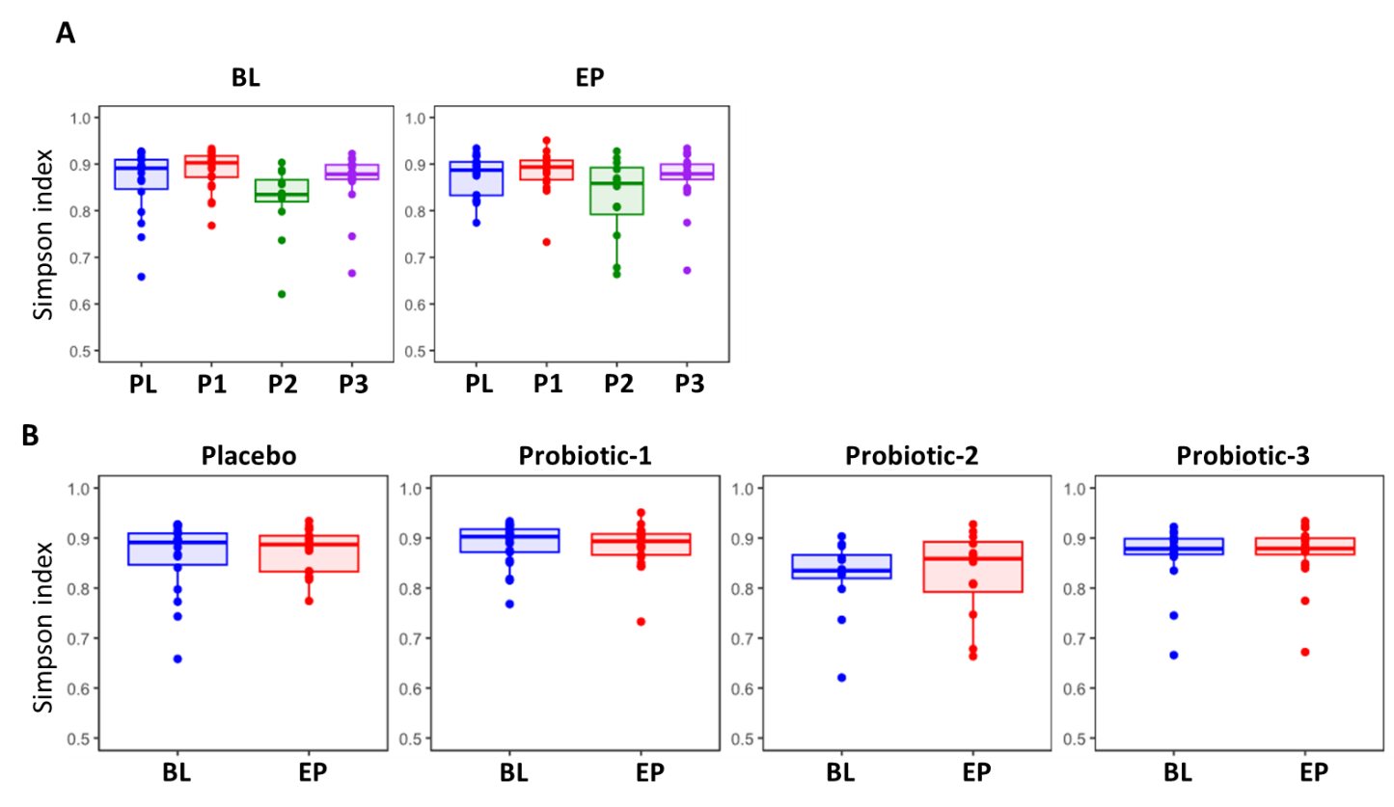

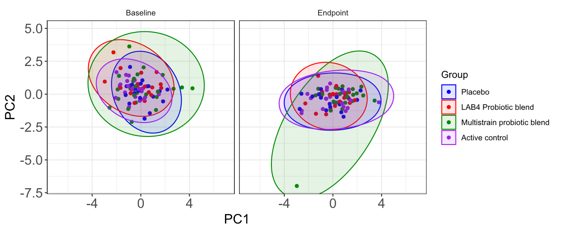
Placebo
P1
P2
P3

SUPPLEMENTARY FIGURE S1. Changes in Simpson α-diversity measure comparing (A) the Baseline (BL) and Endpoint (EP) between groups and (B) the within group for the PL, P1, P2 and P3 groups at the baseline and at endpoint.

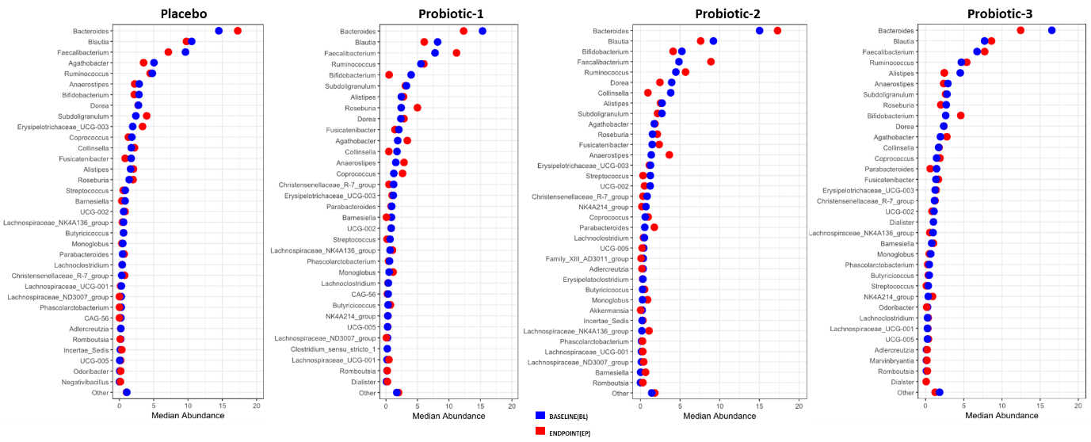

SUPPLEMENTARY FIGURE S2. Dumbbell plots showing changes in the relative median abundance between baseline and endpoint for the 30 most prevalent bacterial genera within the PL, P1, P2 and P3 groups. Data is presented in descending order of abundance according to baseline.
Supplementary Table S1: Baseline demographics

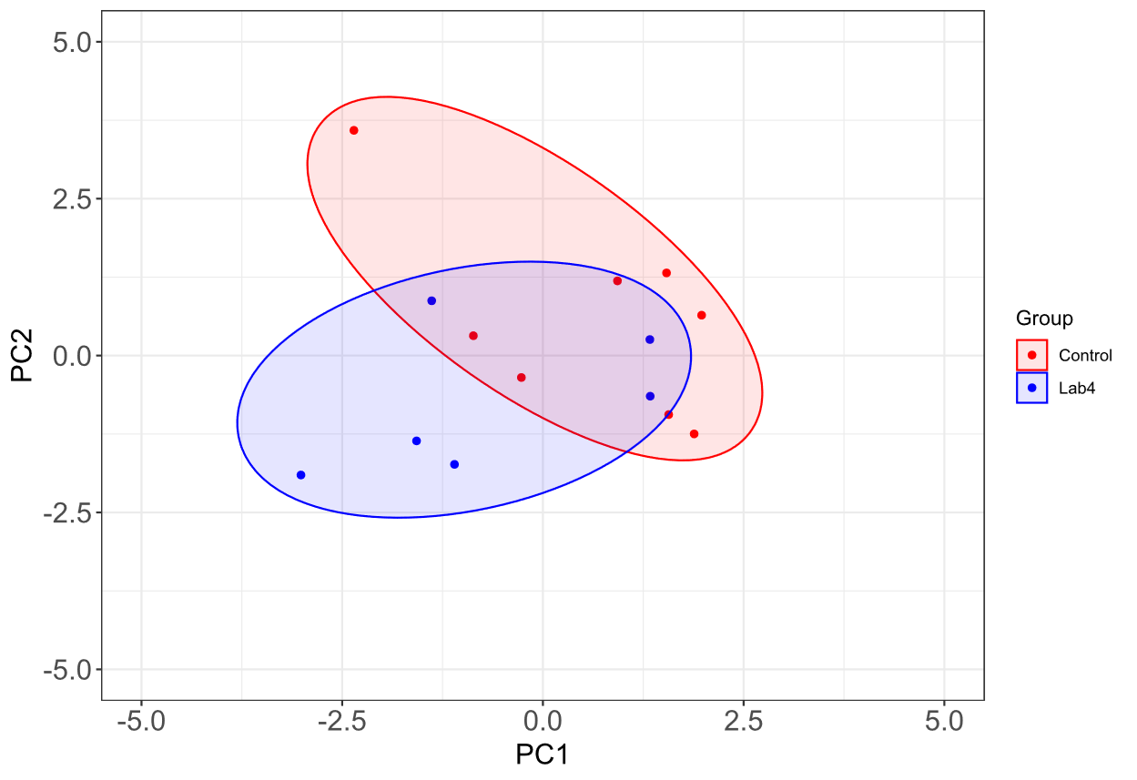
Placebo
Probiotic-1

Supplementary Table S2: Keystone taxa per centrality measure

Supplementary Table S3. Summary statistics: Faecal short chain fatty acids

Supplementary Table S4. Summary statistics: Serum short chain fatty acids

Supplementary Table S5. Summary statistics: Faecal bile acids (Relative Intensity)

Supplementary Table S5. Continued

Supplementary Table S5. Continued

Supplementary Table S5. Continued

